# Security test

For detecting bugs, errors and any defects on the systems security test are used. The security of the page is advanced in both level application and service and outlook level also.

For protecting data and operation on their wish in an IT system that happened on a security checkup system. It’s assumed that any kind of harmful access is restricted. The system of security check is given below:

|  |  |  |  |  |  |
| --- | --- | --- | --- | --- | --- |
| **Id** | **Title** | **Pre-Condition** | **Test Step** | **Actual Result** | **Excepted Result** |
| **5.1** | Field validation | User must be visiting the site | Fill-up input field | Field validate correctly | Except |

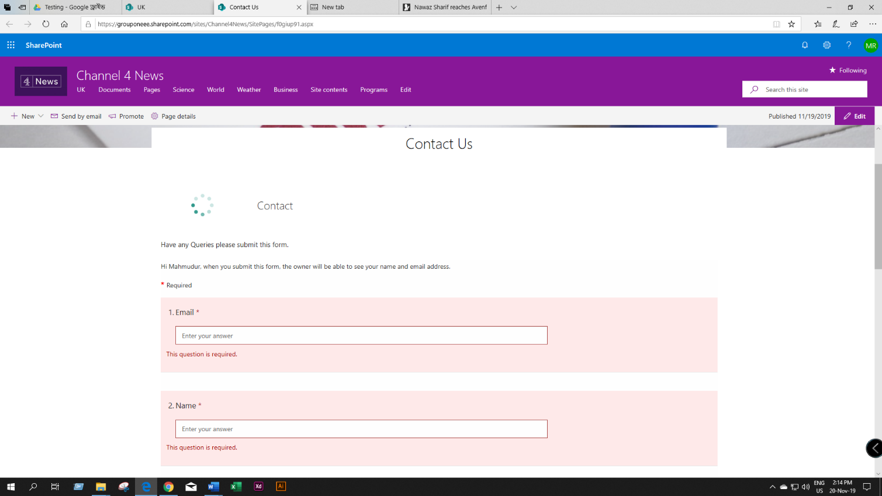

Figure : Input field validation

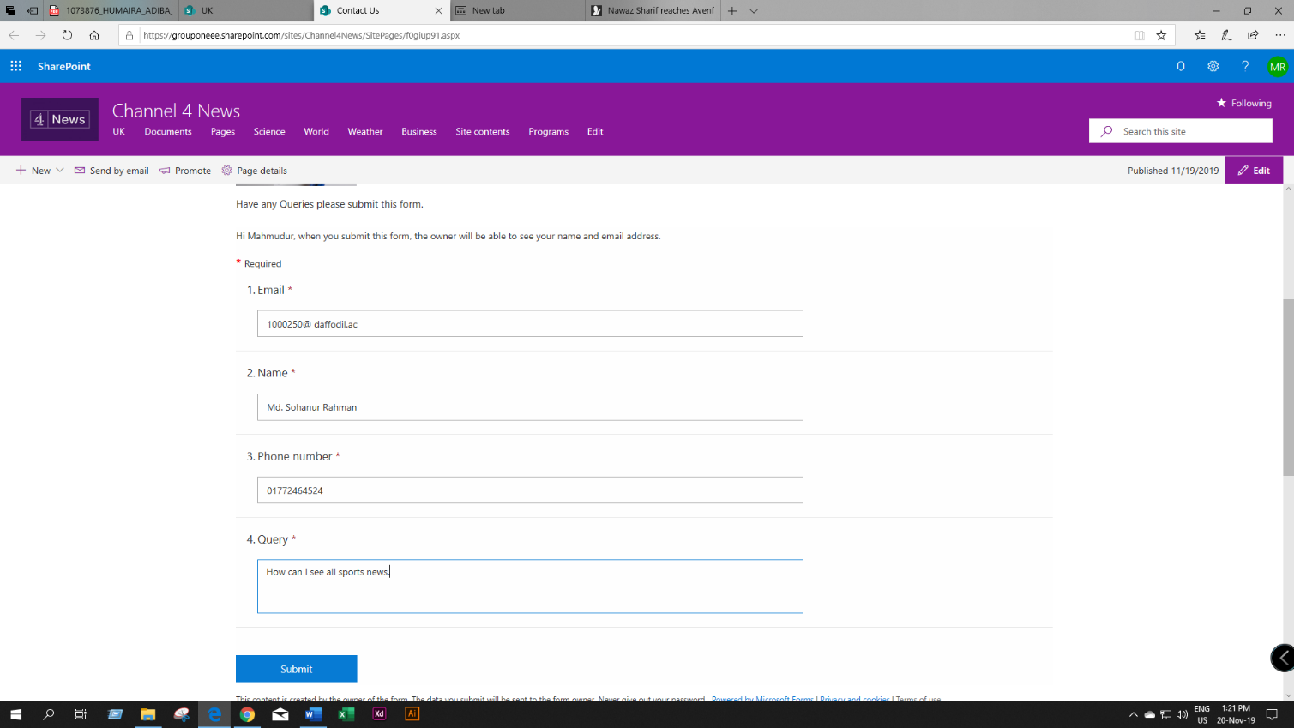

Figure : page validation

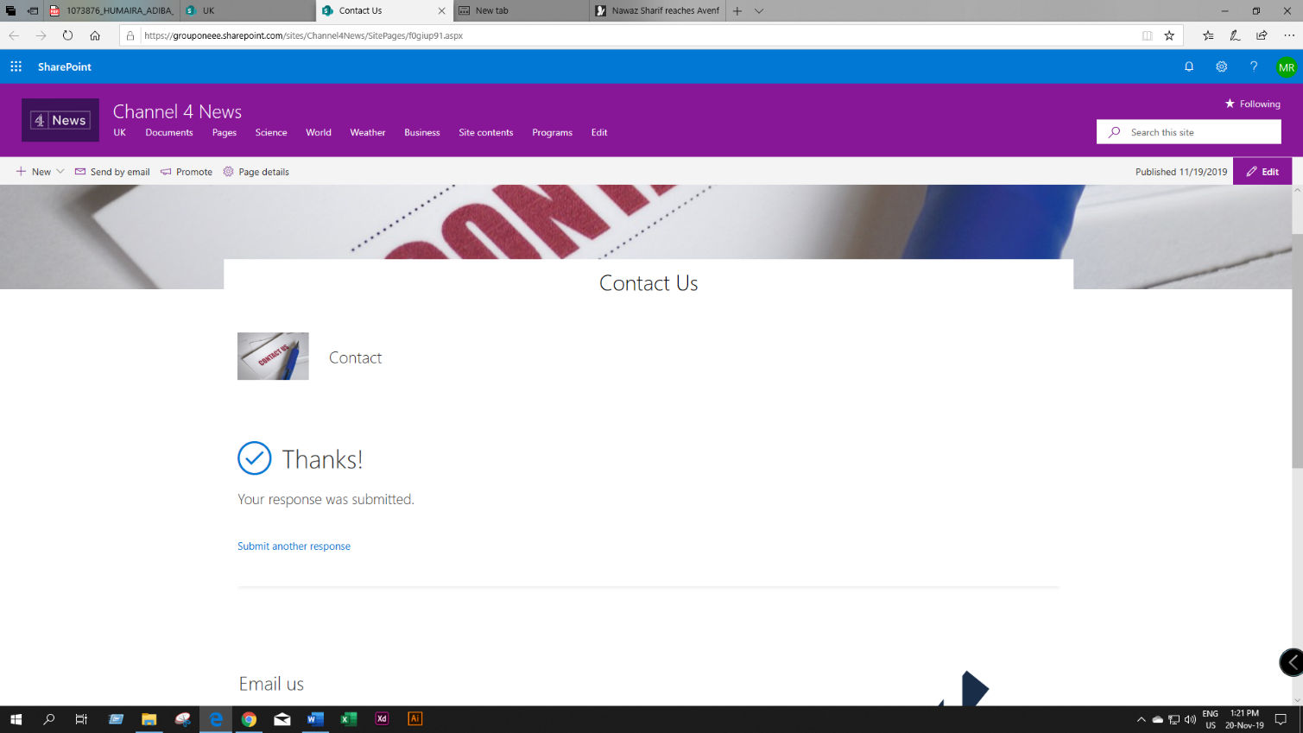

Figure : Validation successful